**Visualisation3:**

In this part, we look for the evolution of names given to gender 1, gender 2 and especially both gender. We plot the 10 most popular names in each three cases: 10 most popular names of gender 1, 10 most popular of gender 2, and 10 most popular of both genders.

As we can see in the line plot, some popular names given to both genders are also popular within each gender, in aggregate we have 20 Names that cover the three cases instead of 30 names.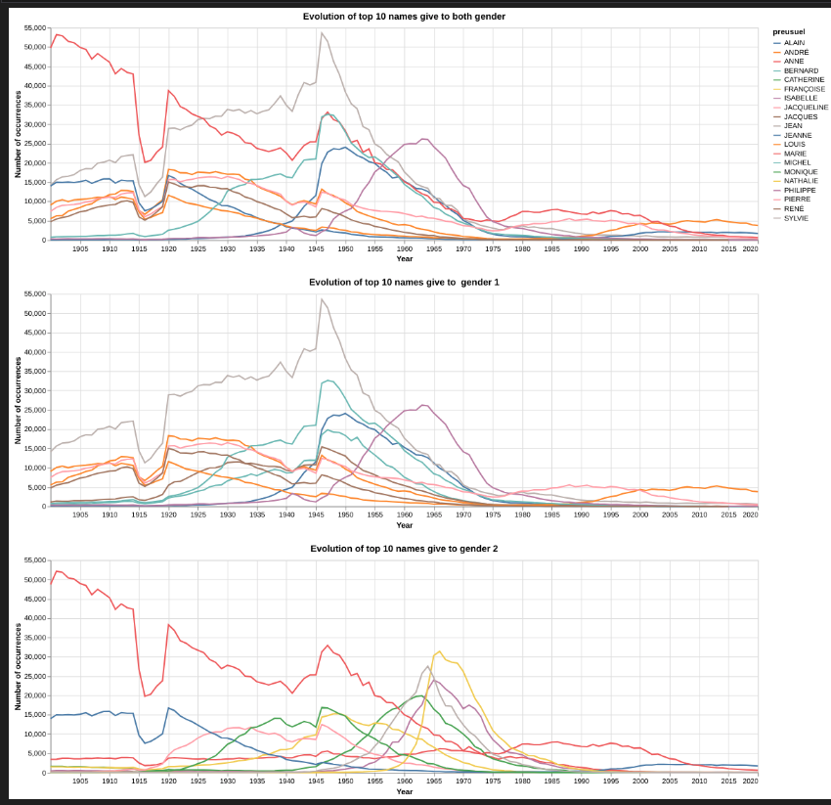

We then want to watch the neutrality of names given to both genders.

we plot the line chart of the difference within each name between the number of names give to gender 2 and number of name given gender 1. We first wanted to plot the relationship gender2/gender1 but this one is little bit bias.

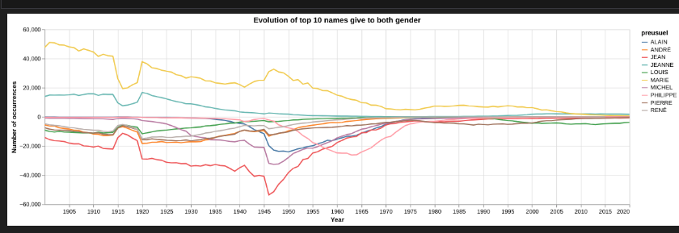

Even if the names are give to both gender some are more neutral than other, Name like PHILIPPE has been more neutral until 1950, It has then been give to many children of gender 1. In other hand names like MARIE or Jean are more categorit to one gender.

Here some name that have change from on gender to another one

